SHODAN FOR EXTERNAL ATTACK SURFACE MANAGEMENT
Tool: Shodan
Topic: External Attack Surface Management (EASM)
Prepared by: Chetna Solanki
1. Introduction
Modern organizations have many internet-facing assets such as web servers, cloud infrastructure, remote services, and network devices. If these assets are publicly exposed, they can increase the organization's external attack surface.
Shodan is a search engine designed to index information about internet-connected devices and services. Security teams can use Shodan to understand what infrastructure is publicly visible and identify services that may require security review.
This blog explains how Shodan can be used as part of External Attack Surface Management (EASM).
2. What is Shodan?
Shodan is a search engine for internet-connected devices and services.
Unlike traditional search engines that mainly index web pages, Shodan can collect technical information from publicly reachable services.
Depending on the indexed host, Shodan may display information such as:
- IP address
- Open ports
- Network services
- Service banners
- Software information
- Software versions
- SSL/TLS certificate information
- Organization and ISP information
- Geographic information

This information can help security professionals understand the externally visible attack surface.
3. What is External Attack Surface Management?
External Attack Surface Management (EASM) is the process of identifying, monitoring, and assessing an organization's assets that are visible from the public internet.
The external attack surface may include:
- Web servers
- Internet-facing applications
- APIs
- Cloud services
- VPN services
- Remote administration services
- DNS infrastructure
- Publicly exposed network services
The main objective of EASM is to discover unknown or unnecessary exposure and reduce security risk.
4. Shodan and EASM
Shodan can support EASM by providing visibility into publicly indexed infrastructure.
A security team can use Shodan to:
1. Identify publicly indexed hosts.
2. Review exposed ports.
3. Identify services running on those ports.
4. Review banners and software information.
5. Identify potentially outdated or unnecessary services.
6. Compare observed assets with the organization's approved asset inventory.
7. Recommend appropriate remediation.

Shodan should therefore be considered a visibility and reconnaissance source rather than proof that a system is vulnerable.
5. Target Organization
Target Organization: Microsoft
Objective:
To demonstrate how organization-based Shodan searches can be used to study publicly indexed internet-facing services.
Method:
The research uses passive reconnaissance of information already indexed by Shodan. No exploitation, authentication testing, vulnerability exploitation, or unauthorized access was performed.
6. Day 1 — Shodan Research and Search Planning
6.1 Understanding Shodan
The first step was to understand the capabilities of Shodan and its relevance to External Attack Surface Management.
The main areas considered were:
- Host discovery
- Port discovery
- Service identification
- Banner analysis
- Software/version visibility
- SSL/TLS information
- Organization-based searches
6.2 Organization-Based Search
An organization-based search can be used to find Shodan-indexed hosts associated with an organization.
The planned query was:
"org:"Microsoft""
This query is intended to identify Shodan-indexed results associated with Microsoft.
The returned results should be treated as publicly indexed observations and should be validated against authoritative asset information before considering them confirmed organizational assets.
6.3 Planned Service Queries
The following queries were prepared for the practical phase:
"org:"Microsoft" port:80"
This can be used to review HTTP-related results.
"org:"Microsoft" port:443"
This can be used to review HTTPS-related results.
"org:"Microsoft" port:22"
This can be used to review SSH-related results if such results are indexed.
These queries provide a simple way to investigate commonly exposed services.
7. Day 1 Findings
The Day 1 research established that Shodan can provide useful visibility into internet-facing infrastructure.
The planned workflow was:
Organization → Hosts → Ports → Services → Banners/Versions → Risk Review → Remediation
The next phase was to execute the planned searches and document relevant publicly indexed service information.
8. Day 2 — Practical Shodan Search
8.1 Organization Search
The first practical search was:
"org:"Microsoft""
The results were reviewed to understand the types of publicly indexed hosts and services associated with the selected organization.
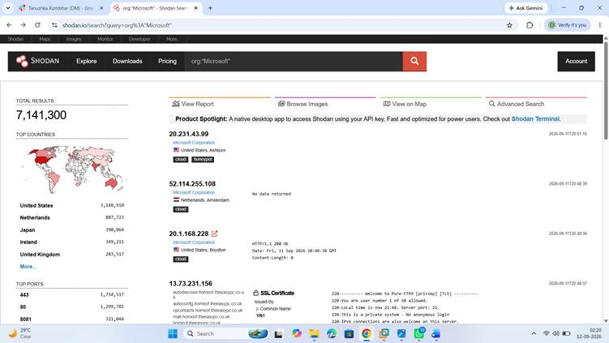8.2 HTTP Service Search
The following query was used:
"org:"Microsoft" port:80"
Port 80 is commonly associated with HTTP services.
The search results were reviewed for publicly indexed hosts where the service information was available.
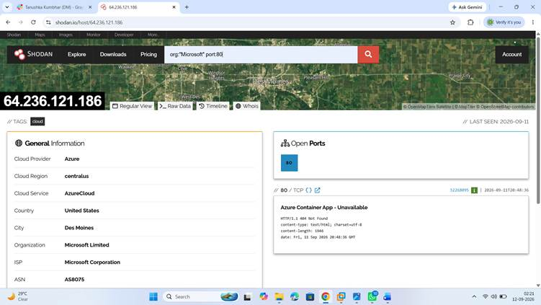
8.3 HTTPS Service Search
The following query was used:
"org:"Microsoft" port:443"
Port 443 is commonly associated with HTTPS services.
The results can provide information about publicly indexed HTTPS services and, where available, related service or TLS information.
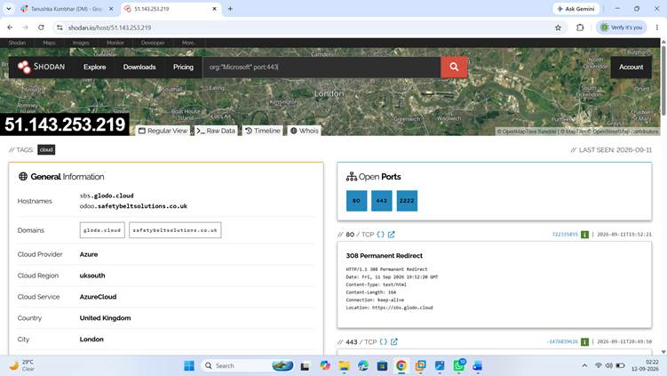8.4 SSH Service Search
The following query was used:
"org:"Microsoft" port:22"
Port 22 is commonly associated with SSH.
This query was used only to review publicly indexed information. No connection attempt or authentication testing was performed.
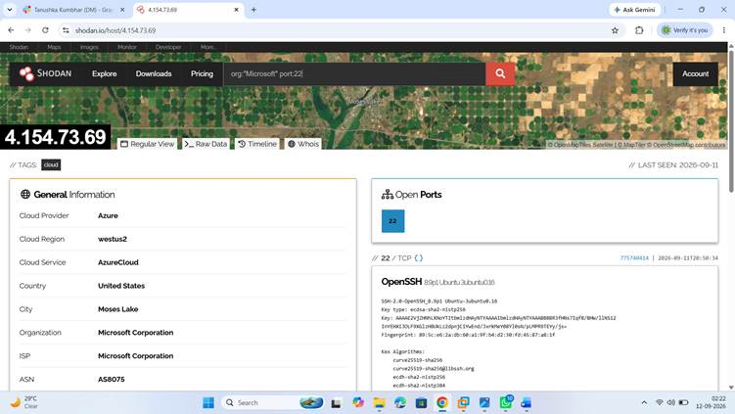
9. Service Exposure Analysis
The observed information can be categorized into several areas:
Public Hosts
Shodan can identify hosts that have been observed on the public internet.
Open Ports
Ports provide an indication of which network services may be publicly reachable.
Services
Service information can help identify the technology or protocol exposed through a particular port.
Software and Versions
Where available, software and version information can help security teams determine whether further patch or configuration review is required.
SSL/TLS Information
Certificate and TLS information can provide additional visibility into HTTPS infrastructure.
10. Risk Assessment
Public exposure does not automatically mean that a system is vulnerable.
However, unnecessary or poorly configured internet-facing services can increase an organization's attack surface.
Potential risks include:
- Unnecessary service exposure
- Outdated software
- Weak service configuration
- Exposed administrative interfaces
- Misconfigured web services
- Poor TLS configuration
- Unknown or unmanaged assets
Each finding should therefore be validated by the organization's security team before assigning a vulnerability or severity rating.
11. Recommendations
Based on the EASM approach, organizations should consider the following recommendations:
11.1 Remove Unnecessary Services
Services that do not need to be publicly accessible should be disabled or restricted.
11.2 Restrict Administrative Services
Management services should not normally be exposed broadly to the public internet. Access should be restricted using firewalls, VPNs, allowlists, or other appropriate controls.
11.3 Keep Software Updated
Internet-facing software should be regularly patched and updated to reduce exposure to known vulnerabilities.
11.4 Review Firewall Rules
Firewall and access-control rules should be reviewed regularly to ensure that only required services are exposed.
11.5 Monitor External Assets
Organizations should continuously monitor their internet-facing infrastructure to identify newly exposed or forgotten assets.
11.6 Maintain an Asset Inventory
Shodan observations should be compared with the organization's approved asset inventory to identify potentially unknown or unmanaged infrastructure.
11.7 Review TLS Configuration
HTTPS services should use secure TLS configurations and valid certificates.
12. Benefits of Shodan for EASM
Shodan can provide several benefits for security teams:
- Faster external asset discovery
- Visibility into exposed services
- Identification of publicly observable technologies
- Support for attack surface monitoring
- Assistance with security exposure reviews
- Identification of potentially unmanaged assets
Shodan can therefore be useful as one source of information within a broader EASM process.
13. Limitations
Shodan does not provide a complete picture of an organization's attack surface.
Some limitations include:
- Shodan results depend on its scanning and indexing.
- Results may not represent the organization's complete infrastructure.
- Organization attribution may require validation.
- A publicly visible service is not necessarily vulnerable.
- Information may become outdated.
- Additional security tools and authoritative asset inventories are required for complete assessment.
14. Conclusion
Shodan provides valuable visibility into publicly observable internet-facing infrastructure.
For External Attack Surface Management, it can help security teams discover hosts, identify exposed ports and services, review publicly visible technology information, and identify assets that may require further investigation.
The practical exercise demonstrated an organization-based search strategy followed by service-specific searches.
The results should be treated as reconnaissance information and validated before making security or vulnerability claims.
15. Ethical and Legal Notice
This research was conducted for cybersecurity learning and defensive security purposes.
Only publicly indexed information was reviewed. No exploitation, credential attacks, vulnerability exploitation, unauthorized access, or intrusive testing was performed.
Security professionals should only assess systems they own or have explicit authorization to test.

